Project Experience
Local Plan Viability Assessment – Central Bedfordshire Council
 |  | Background
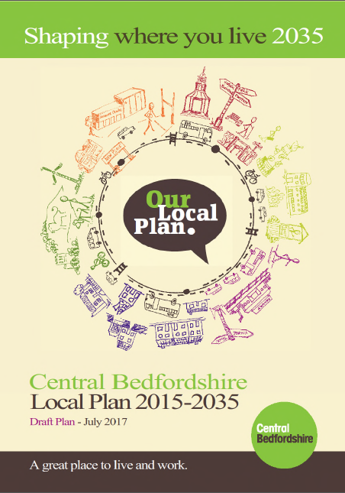 |  | AspinallVerdi has been appointed to support Central Bedfordshire Council to appraise the viability of their new Local Plan.  CBC’s growth strategy already provides 39,350 homes and 24,000 jobs between 2015-2035. However, the housing need figure for Central Bedfordshire may be increased by as much as 60% if the governments ’Planning for the right homes in the right places’ consultation on the new methodology for calculating housing need is imposed.  The Full Council voted to robustly challenge the proposed new methodology through the consultation process. However, it has also resolved to allow for consultation on the next version of the Local Plan in January 2018 with submission in March 2018. This will enable the Plan to be examined on the previous housing figures. This is a very challenging timescale.
 |  | Services
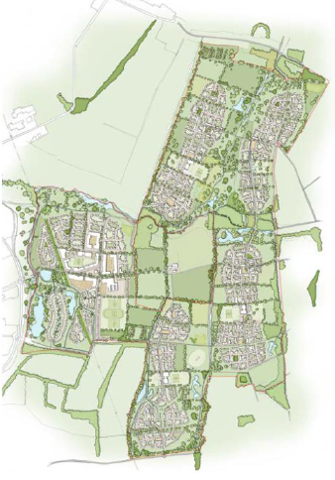  Land East of Biggleswade Illustrative Masterplan (source PBA) |  | AspinallVerdi has:  - Reviewed the residential property market in Bedfordshire to determine high, medium and lower value market areas.  - Developed a database of land value data (transaction, EVAs etc.) to inform the Threshold / Benchmark Land Values across the District.  - Reviewed all the policies in the new Local Plan in so far as they impact on viability.  - Developed a bespoke appraisal to provide detailed sensitivity analysis of the impact on viability of the Council’s affordable housing target, S106 etc.  - Appraised c20,000 units at strategic urban extension locations including: East of Biggleswade, East of Arlesey, Marston Thrift, Marston Vale new villages, and North Luton.  - AspinallVerdi is also on the Panel of site specific S106 viability consultants in Central Beds.  - We have also previously worked on a B1 office market study and unlocking sites and premises study.

