Project Experience
Woods Lane, Cradley Heath, Sandwell, Sandwell Metropolitan Borough Council
 |  | Outline
AspinallVerdi were commissioned by Sandwell Metropolitan Borough Council to assist in the acquisition and negotiation of a 1,409 sqm industrial building, on a 0.59-acre site at Cradley Heath in Sandwell.

This acquisition was the result of an earlier piece of work completed by AspinallVerdi which assessed the costs of land assembly of this historic employment area for planned residential redevelopment.

 |  | Services Provided
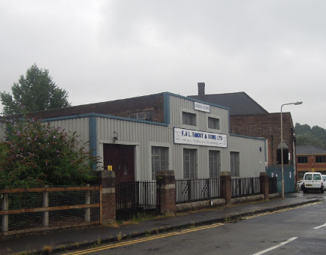 |  | AspinallVerdi provided the following services:  - Initial valuation advice in terms of the market value of the property.  - Undertaking inspection and measurement of the property and then negotiation with the property owner a purchase price.  - Providing advice on the Disturbance Costs claimable by the owner in relocating their business.  - Producing a Red Book Valuation to confirm this purchase price and to support decisions and funding draw down.

 |  | Outputs
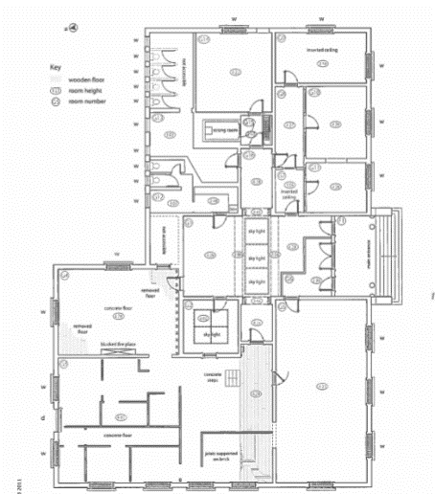 |  | AspinallVerdi successfully negotiated the acquisition of the industrial unit. This enabled the proposed residential development to take place close to the Town Centre and train station of Cradley Heath.

